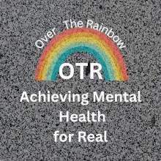
OTR -Achieving Mental Health for Real Podcast Guest Questionnaire
Please insert your answers as needed and return them to me in an email or attached to an email. I am swamped with requests but wanted to be fair in choosing guests based on what I think best fits the show’s mission. To end NEEDLESS suffering and the hurtful stigma of mental health, for real. Finally, if you have any of these answers in your PodMatch profile, you can say “See PodMatch”, except, please fill in the “About You “ section.
1. About You:
- Full Name:
- Preferred Name (if different):
- Role/Title/Profession:
- Short Bio (1-2 sentences):
2. Your Story and/or Expertise:
- What’s your mental health condition including diagnosis and/or area of expertise in the Mental health field?

- If recovery story , do you feel that you are fully recovered or is it at least manageable.

3. Podcast Content:
- What topics would you love to discuss during the episode?
- Is there a question you wish people would ask you, but they never do?
4. Past Podcast Appearances (Optional but Encouraged):

- Have you appeared on any podcasts before? If so, please list a few titles or links that reflect your voice, stance, or story.

- Do you have a link to a podcast that you appeared on recently that you thought best represented you?

